|  |  |
| --- | --- |
| Iraqi Journal for Electrical and Electronic Engineering  *Original Article or Review Article or Short Article* | *Open Access*  IJEEE_Logo |

Article Title for Iraqi Journal for Electrical and Electronic Engineering

**Author One**\*1, **Author Two**2,3, **Author Three**3

1Org Division, Org Name, State Name, Country Name

2Org Division, Org Name, State Name, Country Name

3Org Division, Org Name, State Name, Country Name

**Correspondence**

\*Corresponding Author name

Corresponding address

Email: [authorone@gmail.com](mailto:authorone@gmail.com)

**Abstract**

***The abstract should not exceed 250 words. It should briefly summarize the essence of the paper and address the following areas without using specific subsection titles.): Objective: Briefly state the problem or issue addressed, in language accessible to a general scientific audience. Technology or Method: Briefly summarize the technological innovation or method used to address the problem. Results: Provide a brief summary of the results and findings. Conclusions: Give brief concluding remarks on your outcomes. Clinical Impact: Comment on the translational aspect of the work presented in the paper and its potential clinical impact. Detailed discussion of these aspects should be provided in the main body of the paper.***

***(Note that the organization of the body of the paper is at the authors’ discretion; the only required sections are Introduction, Methods and Procedures, Results, Conclusion, and References. Acknowledgements and Appendices are encouraged but optional.***

**Keywords**

**At least four keywords or phrases in alphabetical order, separated by commas.**

# Introduction

Your goal is to simulate the usual appearance of papers in *IJEEE Journal*. For items not addressed in these instructions, please refer to the last issue of *IJEEE Journal* for reference or ask Publications Chair for instructions.

## Preparing Your Paper

### Paper Size:

Prepare your paper in full-size format on US letter size paper (8.5 by 11 inches).

### Type Sizes and Typefaces:

Follow the font type sizes specified in Table I. The font type sizes are given in points, same as in the MS Word font size points. Times New Roman is the preferred font.

### Paper Margins:

Paper margins on the US letter size paper are set as follows: top = 0.75 inches, bottom = 1 inch, side = 0.625 inches. Each column measures 3.5 inches wide, with a 0.25-inch gap between the two columns.

TABLE I.

Type Size for Papers

|  |  |  |  |
| --- | --- | --- | --- |
| Type size | Appearance | | |
| Regular | Bold | Italic |
| 10 | Section titles,  references,  table captions,  figure captions. |  |  |
| 10 |  | Abstract, Keywords. | Abstract |
| 10 | Main text,  equations. |  | Subheading |
| 10 | Authors' names | Authors' names |  |
| 22 | Paper title | Paper title |  |

### Paper Styles:

Left- and right-justify the columns. On the last page of your paper, adjust the lengths of the columns so that they are equal. Use automatic hyphenation and check spelling and grammar. Use high resolution (300dpi or above) figures, plots, drawings and photos for best printing result.

# Helpful Hints

## Figures and Tables

Try to position figures and tables at the tops and bottoms of columns and avoid placing them in the middle of columns. Large figures and tables may span across both columns. Figure captions should be centered below the figures; table captions should be centered above. Avoid placing figures and tables before their first mention in the text. Use the abbreviation “Fig. #,” even at the beginning of a sentence.

In case of dimensions of the figure are equal to the page width, it can be inserted as in Fig. 1.

Figure axis labels are often a source of confusion. Use words rather than symbols. For example, as shown in Fig. 1, write “Magnetization,” or “Magnetization (M)” not just “M.” Put units in parentheses. Do not label axes only with units. In the example, write “Magnetization (A/m)” or “Magnetization (A⋅m-1).” Do not label axes with a ratio of quantities and units. For example, write “Temperature (K),” not “Temperature/K.”

Multipliers can be very confusing. Write “Magnetization (kA/m)” or “Magnetization (103 A/m).” Figure labels should be legible, at 8-point type.

## References

Number citations consecutively in square brackets [1]. Punctuation follows the bracket [2]. Refer simply to the reference number, as in [3]. Use “Ref. [3]” or “Reference [3]” at the beginning of a sentence: “Reference [3] was the first …”

Number footnotes separately in superscripts. Place the actual footnote at the bottom of the column in which it was cited. Do not put footnotes in the reference list. Use letters for table footnotes (see Table I). *IJEEE Journal* no longer use a journal prefix before the volume number. For example, use “*IEEE Trans. Magn.*, vol. 25,” not “vol. MAG-25.”

Give all authors’ names; use “et al.” if there are six authors or more [4]. Papers that have not been published, even if they have been submitted for publication, should be cited as “unpublished” [4]. Papers that have been accepted for publication should be cited as “in press” [5]. In a paper title, capitalize the first word and all other words except for conjunctions, prepositions less than seven letters, and prepositional phrases.

For papers published in translated journals, first give the English citation, then the original foreign-language one [6].

## Abbreviations and Acronyms

Define abbreviations and acronyms the first time they are used in the text, even if they have been defined in the abstract. Abbreviations such as IEEE, SI, MKS, CGS, ac, dc, and rms do not have to be defined. Do not use abbreviations in the title unless they are unavoidable.

## Equations

Number equations consecutively with equation numbers in parentheses flush with the right margin, as in (1). To make your equations more compact, you may use the solidus (/) and the exp function, etc. Italicize Roman symbols for quantities and variables, but not Greek symbols. Use an en dash (–) rather than a hyphen for a minus sign. Use parentheses to avoid ambiguities in denominators. Punctuate equations with commas or periods when they are part of a sentence, as in

$\cos^{3}θ=\frac{1}{4}\cos{θ}+\frac{3}{4}\cos{3θ}$ (1)

Symbols in your equation should be defined before the equation appears or immediately following. Cite equations using “(1),” not Eq. (1)” or “equation (1),” except at the beginning of a sentence: “Equation (1) is …”

## Other Recommendations

The Roman numerals used to number the section headings are optional. Do not number Acknowledgement and References and begin Subheadings with letters. Use two spaces after periods (full stops). Hyphenate complex modifiers: “zero-field-cooled magnetization.” Avoid dangling participles, such as, “Using (1), the potential was calculated.” Write instead, “The potential was calculated using (1),” or “Using (1), we calculated the potential.”

Use a zero before decimal points: “0.25,” not “.25.” Use “cm3,” not “cc.” Do not mix complete spellings and abbreviations of units: “Wb/m2” or “webers per square meter,” not “webers/m2.” Spell units when they appear in text: “…a few henries,” not “…a few H.” If your native language is not English, try to get a native English-speaking colleague to proofread your paper. Do not add page numbers.

# Units

Use either SI (MKS) or CGS as primary units. (SI units are encouraged.) English units may be used as secondary units (in parentheses). An exception would be the use of English units as identifiers in trade, such as “3.5-inch disk drive.”

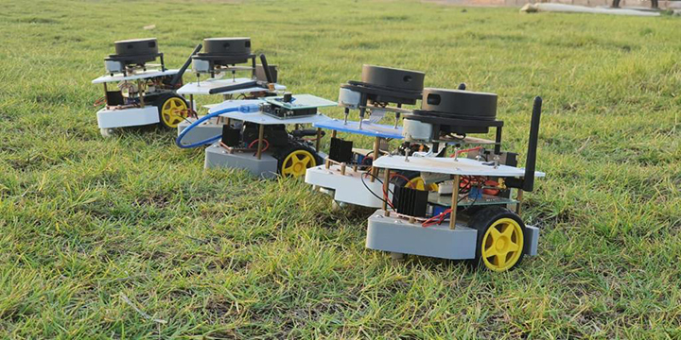

Fig. 1. Wide Picture

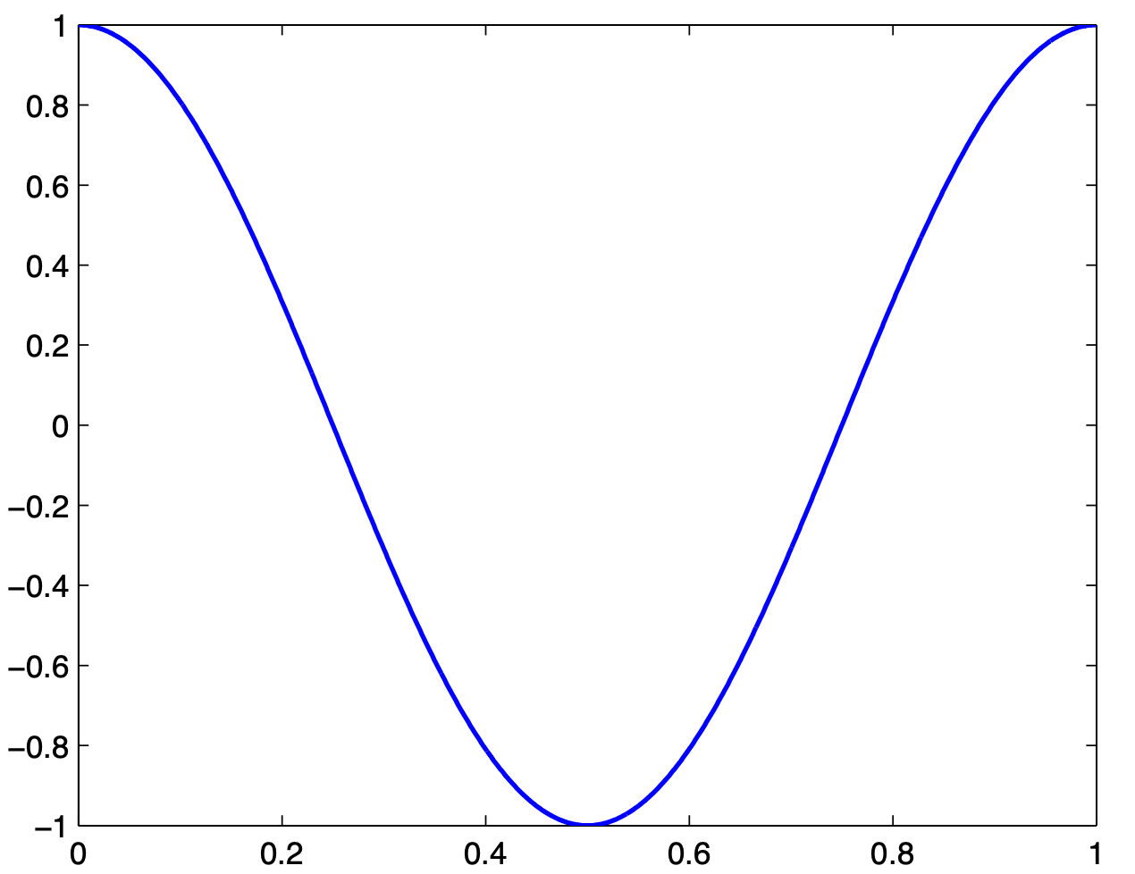

Magnetization (kA/m)

Applied Field (103 A/m)

Fig. 2. Magnetization as a function of applied field.

Note how the caption is centered in the column.

Avoid combining SI and CGS units, such as current in amperes and magnetic field in oersteds. This often leads to confusion because equations do not balance dimensionally. If you must use mixed units, clearly state the units for each quantity that you use in an equation.

# Some Common Mistakes

The word “data” is plural, not singular. In American English, periods and commas are within quotation marks, like “this period.” A parenthetical statement at the end of a sentence is punctuated outside of the closing parenthesis (like this). (A parenthetical sentence is punctuated within the parentheses.) A graph within a graph is an “inset,” not an “insert.” The word alternatively is preferred to the word “alternately” (unless you mean something that alternates). Do not use the word “essentially” to mean “approximately” or “effectively.” Be aware of the different meanings of the homophones “affect” and “effect,” “complement” and “compliment,” “discreet” and “discrete,” “principal” and “principle.” Do not confuse “imply” and “infer.” The prefix “non” is not a word; it should be joined to the word it modifies, usually without a hyphen. There is no period after the “et” in the Latin abbreviation “et al.” The abbreviation “i.e.” means “that is,” and the abbreviation “e.g.” means “for example.” An excellent style manual for science writers is [7].

# Acknowledgment

The preferred spelling of the word “acknowledgment” in America is without an “e” after the “g.” Try to avoid the stilted expression, “One of us (R. B. G.) thanks …” Instead, try “R.B.G. thanks …” Put sponsor acknowledgments in the unnumbered footnote on the first page.

# Conflict of Interest

If authors have no conflict of interest, they must also state this when applying in the same submitted manuscript in the conflict of interest section and the phrase (The authors have no conflict of relevant interest to this article.) can be used.

# References

1. M. King, B. Zhu, and S. Tang, “Optimal path planning,” *Mobile Robots*, vol. 8, no. 2, pp. 520-531, 2001.
2. H. Simpson, *Dumb Robots*, 3rd ed., Springfield: UOS Press, 2004, pp.6-9.
3. M. King and B. Zhu, “Gaming strategies,” in Path Planning to the West, vol. II, S. Tang and M. King, Eds. Xian: Jiaoda Press, 1998, pp. 158-176.
4. B. Simpson, et al, “Title of paper goes here if known,” unpublished, 2020.
5. J. G. Lu, “Title of paper with only the first word capitalized,” *J. Name Stand. Abbrev.*, 2022.
6. Y. Yorozu, M. Hirano, K. Oka, and Y. Tagawa, “Electron spectroscopy studies on magneto-optical media and plastic substrate interface,” *Digest 9th Annual Conf. Magnetics Japan*, August 1987.
7. M. Young, *The Technical Writer’s Handbook*, Mill Valley, CA: University Science, 1989.